
Department of Engineering Technology
Foundation University Islamabad
School of Science and Technology

Course: Introduction to Web Technology Lab
Lab IV Manual
Name:
Roll no:

Topic: CSS3 Concepts and Responsive Web Design
Performance |  |  | Lab Report
Description | Total Marks | Marks Obtained | Description | Total Marks | Marks  Obtained
Implementation of CSS and Responsive Designs | 5 |  | UI Design and Code Equality with Report | 5
Total Marks obtained

Lab Objectives
After completing this lab, students will be able to:
- Understand and apply different CSS selectors
- Use CSS box model and layout properties
- Design layouts using Flexbox and Grid
- Implement responsive design using media queries
- Apply CSS styling to build a structured webpage

- CSS Selectors
CSS selectors are used to select HTML elements and apply styles to them.
Types of Selectors
1. Element Selector
Selects all elements of a specific type.

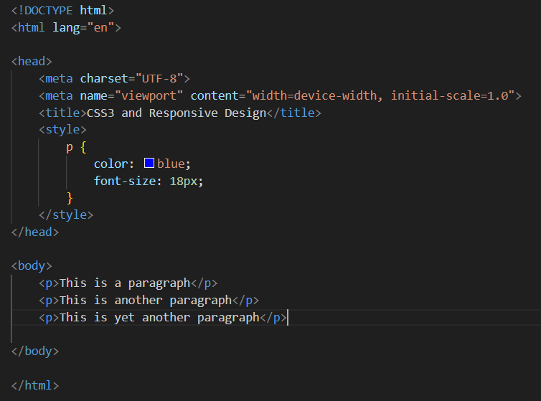

2. Class Selector
Used to style multiple elements using the same class.

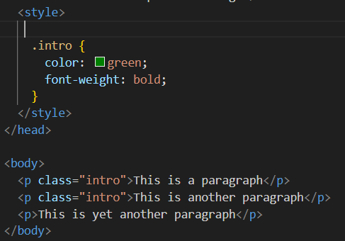

3. ID Selector
Used to style a unique element.

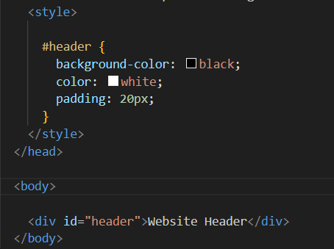

4. Universal Selector
Selects all elements.
The purpose of the universal selector is to apply the same style to every HTML element on the page.

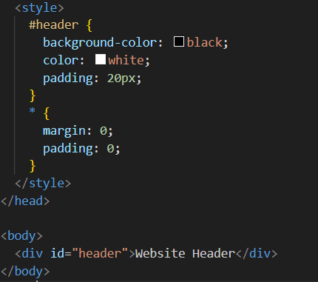

4. CSS Box Model
The CSS box model consists of four parts:
Content - Padding - Border – Margin

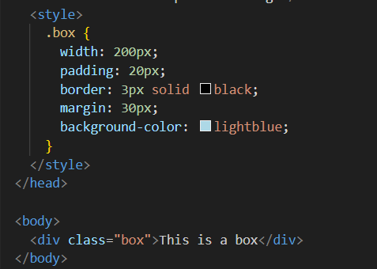

5. Flexbox Layout
Flexbox is used to align and arrange elements in a row or column.

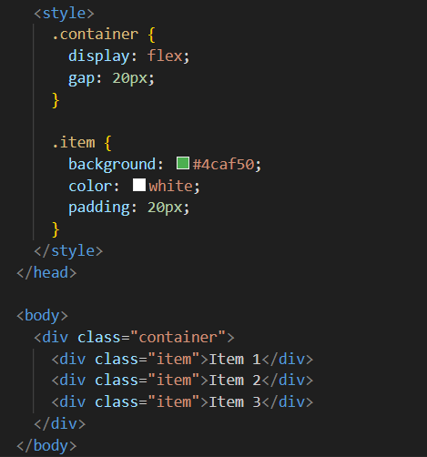
Output:
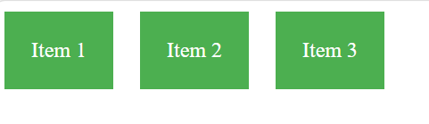
Important flexbox properties

Property | Purpose
display: flex | activates flexbox
justify-content | horizontal alignment
align-items | vertical alignment
flex-wrap | wraps items into next line

6. CSS Grid Layout
Grid layout is used for two-dimensional layouts (rows and columns).
repeat(2,1fr): Create 2 equal columns that share the available space equally.

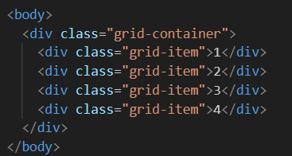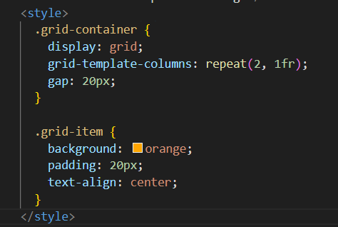

Output:
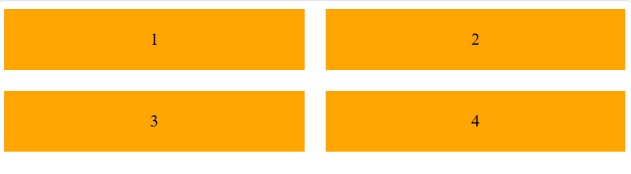
Important Grid Properties
Property | Purpose
display:grid | enables grid layout
grid-template-columns | defines number of columns
grid-template-rows | defines rows
gap | space between grid items

7. Media Queries (Responsive Design)
Media queries allow websites to adapt to different screen sizes.

Example 1: Tablet View
When screen width is 768px or smaller, flex items stack vertically.

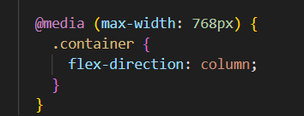

Example 2: Mobile View
This adjusts text size for small devices.
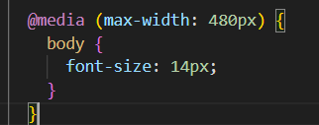

Multiple Media Queries Example

These queries ensure the website works properly on:
- Desktop
- Tablet
- Mobile

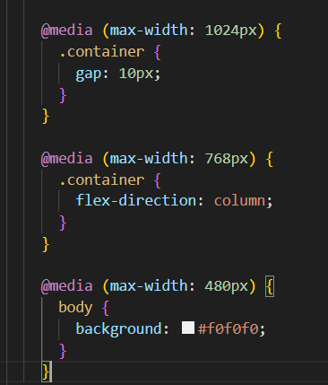

Lab Task
Design a responsive "Student Profile Webpage" that includes:
- Student Information Section
- Skills Section (Flexbox)
- Image Gallery (Grid)
- Contact Section
Requirements:
- Use CSS selectors (element, class, id)
- Apply CSS box model
- Use Flexbox and Grid
- Add at least two media queries
- Apply UI design principles

Lab Report Guidelines
Report Format and Sections:
- Make sure your report is well-organized and easy to follow.
- Use proper headings for each section mentioned above.
- Include screenshots wherever required to demonstrate progress and outputs including Figure Captions.
- Submit the lab report as a document file (Only Word)
- In next Lab You must Submit your Previous lab Report in Printed Form

